Automated Laboratory Workshop with a Remote Access for Open Engineering Education

B. Lipay
National Research University "MPEI"
Moscow, Russia
LipaiBR@mpei.ru
Ivan Stankevich
Dept. of Electrical Complexes of Self-Contained Objects and Electrical Transport
National Research University "MPEI"
Moscow, Russia
A. Berilov
National Research University "MPEI"
Moscow, Russia
BerilovAV@mpei.ru

D. S. Gruzkov
National Research University "MPEI"
Moscow, Russia
Valentina S. Maslova
National Research University "MPEI"
Moscow, Russia
MaslovaVS@mpei.ru

Abstract— The article researches the problems of automated laboratory workshop of remote access generation by means of modern information and communication technologies. It shows that the formation and effective use of the single kit of laboratory equipment makes possible the execution of large number of labs in face-to-face, blended and distance education. In accordance with it students need only the Internet connection. The complex is supplemented with a subsystem of remote computer simulation of the objects of study. The example of the practical application of designed laboratory is shown.
Keywords— Automated laboratory workshop, remote access, physical experiment, computer simulation, distance education, the basics of electronics, electrical engineering, electrical circuits, rectifiers, voltage stabilizers, operational amplifiers.

Introduction
Laboratory workshops play an important role and are the compulsory part of the educational process during the professional preparation of future engineers. Also you need to take the following features into consideration:
1) To implement laboratory workshops with a frontal method you need to create laboratories with a great amount of one and the same type of the equipment and with a great amount of work places. That means that you will need significant financial expenses to organize and to support such laboratories.
2) As a rule large universities possess a developed net of geographically widespread branches as a part of their structure. These branches are equipped with identical sets of laboratory equipment and require additional financial means and organizational efforts.
3) Modern higher education becomes more and more individualized. So each student can learn with an individual educational plan. Then you need to provide him with an opportunity to fulfill individual tasks with laboratory equipment at any time he wishes.
4) Ubiquitous spreading of the global network as the Internet, the development of mobile devices and of the wireless Internet in total with an automation and intellectualization of scientific, productive and household appliances support the search of new approaches to organize educational laboratories. This article investigates the whole structure and the example of automated laboratory workshop with a remote access (ALW RA) realization on the basis of National Research University “MPEI”. This workshop is used to study electronics and electrical engineering, and is capable 24 hours a day support the mass service of remote inquiries of users to implement experiments and/or a computer modeling with unique units of laboratory equipment. Laboratory equipment works in an automatic mode to set the parameters of a received task via computer nets. During the experiment implementation the record of instant current and voltage means of measured data channels of the researched object is provided. Finally all the recorded data is transmitted via computer nets to the user, who realized the experiment.
A remote access to the laboratory equipment is performed by computer nets with the help of stationary computers or mobile devices such as tablets or smartphones with an installed specialized software or web-application, which allow to study methodological materials, to form the task for the experiment, to send it for the execution of the task to accept, to display and to process the experimental data.

The History of the Question and the Modern State
There are some projects aimed to create and apply automated laboratory workshops with a remote access (ALW RA).
So in the USA there is a project World Wide Student Laboratory (http://discoverlab.com, http://wwsl.net) [1-4]. This laboratory allowed students to perform remote experiments in physics, optics, material science, chemistry and biology.
In Massachusetts Technological Institute there is iLab project: Remote Online Laboratories (http://icampus.mit.edu/projects/project/?pname=iLabs). Students are provided with a remote access to different laboratory installations. Initially that was a showcase for microelectronics [5, 6], then laboratories to study dynamic signals, thermo exchange and crystallization of polymers appeared [7].
Also the project iSES (Internet School Experimental System, (Charles University, Prague – http://www.ises.info) deserves attention. This project includes distant laboratories for optics, electrical engineering, electronics and offers means to create new laboratories.
A distant laboratory workshop is actively developed in Australia. In Sidney Technological University (University of Technology Sydney, UTS, http://www.uts.edu.au/about/ faculty-engineering-and-information-technology/what-we-do/ facilities-and-services/remote) along with the projects of remote observation and management of the computer tomograph and of electronic microscope there is a physical model of electrical supply system, which includes the generator, transmission lines and different variations of electrical load. In Royal Melbourne Institute of Technology, RMIT there is a distant laboratory, which is connected with a specially designed institute LabShare (http://www.labshare.edu.au), which provides students with an access to the set of laboratory works for electrical engineering, geology, programming, hydropower engineering, robotics and mechatronics.
Russia possesses leading positions in the sphere of ALW RA. Projects to create and organize the use of laboratories with a remote access via computer nets have been performed by some Russian universities since 1995.
Among them there is MSTU named after N.E. Bauman, where there were distant laboratories such as “Radio-telescope MSTU”, “Materials test”, “Plasma spectrometry” created [8]. Krasnoyarsk State Technical University, which now is a part of Siberian Federal University, where with principals of ALW RA the system of collective use centers with a remote access was created [9, 10].
National Research University “MPEI” is one of the leaders in the sphere of modern informative-communicative technologies applied to create laboratory workshops of new generation. The first successful demonstration of the remote management of the showcase for studying electrical machines installed on the territory of MPEI was performed out of Nizhniy Novgorod in 1996. Hereinafter at active participation of MPEI staff members the concept of ALW RA and a related industrial standard were designed [13]. That allowed to realize the project of ALW RA - PILab (Polytechnic Internet Laboratory).

The Structure of ALW RA
The structure of the automated laboratory workshop is determined by the following general requirements:
- The necessity to handle a great amount of users, who can be at a significant distance of the equipment;
- The time the user waits to get the result of the executed task should not exceed several dozens of seconds;
- Overlap of one and the same type of the equipment must be minimized: the availability of only one set of the equipment to satisfy the inquiries of all users is much desirable;
- Laboratory set must operate 24/7 (around the clock, without any pauses);
- Operational and organizational expenses must be reduced by the way of decrease the weight and size and energy indicators of laboratory equipment, the increase it's reliability, the cooperation of some universities which possess different equipment.
- The interaction of the equipment, setting of the experiment parameters, the output data measuring must be made in automatic mode by means of distant user tasks.
Dependent on the current task and using equipment only the remote monitoring of researched objects or processes can be available, when the user has no opportunity to manage the experiment. The more preferable and didactically valuable experiment is when operated by user, who can set a configuration and parameters of the object. He sets the form and the values of the disturbing effects, the set of measured parameters and then he initiates the start of the experiment with remote equipment and analyses received results.
Considering mentioned requirements, generalized structure of ALW RA can be shown as in Fig.1.
The important part of ALW RA is the software which conditionally can be divided in to three stages:
- Specialized software of the user to interact with a remote equipment, functions of which are the preparation and the transfer of the task to implement, receiving and processing of experiment results;
- Web server software as its function has the organization of sequential implementation of received tasks, the transfer of users data to and from the equipment;
- Software of laboratory equipment which support the setting of the researched object in accordance with the experiment task, experiment duration management, measuring realization and results transfer to the server.
Shown in Fig.1 structure of the ALW RA and the three-staged software were realized within PILab. The main feature of the PILab is the including in the user's software the computer modeling subsystem. That allowed to increase the level of the methodological supply of the laboratory workshop and provided the opportunity to compare the results of modeling and physical experiments. Also methodological recommendations for laboratory works implementation are included in PILab structure.
The variation of software installation is developed to the short connection of the user to the Internet. The rest of the time the student can work autonomously.

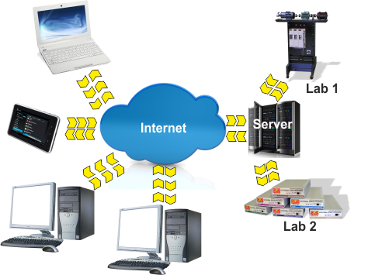
Fig. 1. The structure of ALW RA

At present there are some factors, which allow and make it advisable to refuse from the design and the installation of ALW RA software:
- With a mass distribution of mobile devices the amount of operational systems and their versions, which should be supported by designers of software, significantly increased. This essentially increased labour expenditures to create and accompany specialized user software.
- The amount of users connected to the Internet significantly increased. By the statistics of 2017 [14] in Russia this number was about 90 million a month. Herewith more than 60% of them are the citizens of small towns and cities with the population less than 100 thousands of people.
- The wide spread of mobile Internet. According to the data three quarters of internet connections are via smartphones and tablets.
- Cellular operators actively switch to modern communication standards such as 4G, LTE, 5G. That provides the communication speed comparable with a modern wire connection. So in 3G nets the average speed can be up to 4-5Mb/s, in 4G nets there is up to 100Mb/s, and for the connection of the next generation appearing in the next couple of years there is up to 20 Gb/s. And the cost of the communication service is not high;
- Equipment producers actively take the market with cheap mobile devices (smartphones, tablets etc.), by which users can rather comfortably surf the Internet;
- Wireless nets are actively developed including those with a free access.
So the web-application can be as an alternative for the user. This variation allows refusing from the installation and service of specialized software and gives an opportunity to work with a workshop using any device with the Internet connection.

PILab Equipment
Automated laboratory equipment of PILab is the set of six modules, each of which is mounted in a separate housing of 200x280x60mm and has external jacks for a power grid of 220V 50Hz connection and for the Ethernet connection. Each module is of two boards - object and managing ones.
Object board defines the thematic focus of the PILab module and the amount of laboratory works:
- “Electrical circuits” module is about DC circuits, one and three-phase circuits of AC, AC/DC circuits with reactive elements (8 works);
- “Rectifiers” module is about one-phase one-half period rectifier, one-phase two-half period bridge rectifier, three-phase one-half rectifier, three-phase two-half period rectifier, manageable thyristor one-phase one-half period rectifier (7 works);
- “Voltage regulators” module is about parametric and impulse regulators of voltage (6 works);
- “Operational amplifiers” module is about inverter amplifier, non-inverter amplifier, summing amplifier, differential amplifier, integrator, differentiator, comparator, multivibrator, Schmitt trigger (9 works);
- “Diodes and transistors” module is about volt-amperes characteristics of diodes and transistors of different types (6 works);
- “Microcontrollers” module is about programming of 8-digit microcontroller of 80C51 family (6 works).
The photo of an object board of “Electrical circuits” module is shown as an example in Fig. 2.
EMF sources of DC and AC are performed on the basis of 4-channel of 8-digit digital-analog converter and operational amplifiers. Individual setting of each channel with an opportunity to form voltage signals is included.
Microchips of electronic switch provides necessary configuration of electrical circuits by connecting capacitors, induction coils, resistors in accordance with the experiment task.
Circuits of current and voltage measures are performed with the help of instrumental operational amplifiers.
Managing board is the same to all six modules. It supports the interaction of each module with the external world. Software of the managing board depends on the object board with which it works.
There is a microcontroller on the basis of the digital signal processor. For a remote managing the Ethernet 10BASE-T/100BASE-TX interface with a support of TCP/IP protocols family is performed on this board.
Besides the microcontroller this board has a power supply with output stabilized voltage of +3,3V, four chips of RAM to record experiment data, Ethernet controller and jacks to pair it with an object board.

PILab Web-Application
One of the most modern decisions for mass service of remote users is to create distributed web-applications. Then users interact with a web-page which contains the set of control elements.
The general structure of web-application for PILab is shown in Fig. 3.
This structure includes:

The set of web pages located on the server and opened by the user with his web-browser. They provide the main user interface;

Web-service is a specialized application that works under management of the web server and reacts to the actions of the user. The web service interacts with the database and when it is necessary with the service of the operational system;

Database which contains the information of system users, their activity, modeling sessions performed, of tasks sent and of experiment results received;

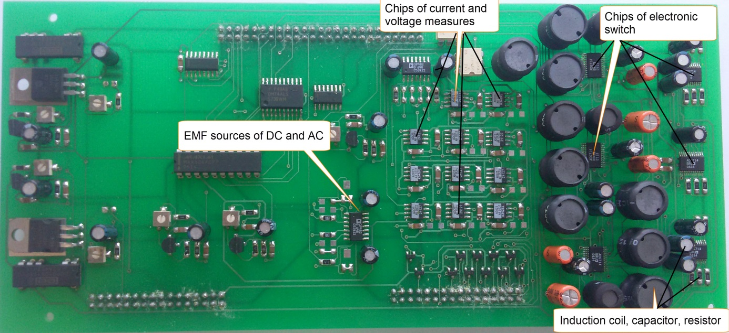
Fig. 2. Object board of “Electrical circuits” module

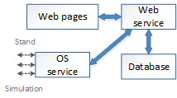
Fig. 3. The structure of the web application

- Operational system service, which performs direct interactions with the server software of PILab and with a modeling system.
The set of user actions is the following:
1) The page login.html is used to log in. If the user is not registered, he can use the link “Registration”. Introduced data are verified and during the registration these data are kept in the database. User session becomes accessible.
2) The user chooses the required object for which the chip appears in the central part of the interface. At the same time, the task for the job is loaded. Simultaneously the task to be implemented is loaded.
3) With the help of the control elements parameters of the object are formed in accordance with the task.
4) The user chooses the type of the work that means experiment or modeling. The task is formed to execute.. It is transferred to the server, kept in the database at the same time and is queued.
5) After the work is finished there are two links “Download” and “Show” available. “Download” link provides the opportunity to keep the result of modeling or experiment in the file with CSV format (Comma Separated Values). This format allows without any transformation to use this file to construct the graph in different programs such as Word, Excel, PTC Mathcad and others. “Show” link allows to display the received results in a graphic form at a separate page of any web-browser with an opportunity to save it in popular formats such as JPG and PNG. So you can consequently prepare the report of your work with the help of any word processor that support the inserting of pictures. Additionally the opportunity to combine the displaying of experiment and modeling results is realized.
If during the task execution there was an error, then in the last column of the table the message of the error would be shown in the tab “Results”.

The Example of the Task Implementation
As the example we will study the process of charging and discharging of the capacitor during the impulse transmission to the RC-circuit of DC voltage. In assembled mode such scheme is shown in Fig. 4. The resistance of resistor R1 is specified as 201.3 Ohm, which is reached by means of parallel connection of available nominals. The same way the volume of the capacitor C2 is specified as 38.9 mkF. Circuit elements C1, L1, R2, L2 are shorted (Fig. 4). Supply voltage is specified in a table form and contains three lines with the following pairs of meanings such as time-dimension 0 s – 0 V, 0.05 s – 1 V, 0.1 s – 0 V. The finite time of modeling and experiment is determined as equal to 150 ms.
Results of modeling and experiment are shown in Fig. 5 and Fig. 6. To be easily compared received graphs are imposed on each other.
The voltage (Fig.6) increases and decreases via exponent to the level of 1 V, as it cannot be changed with the capacitor in a spike form. The time of a transferable process is about 40 ms at the voltage alteration.
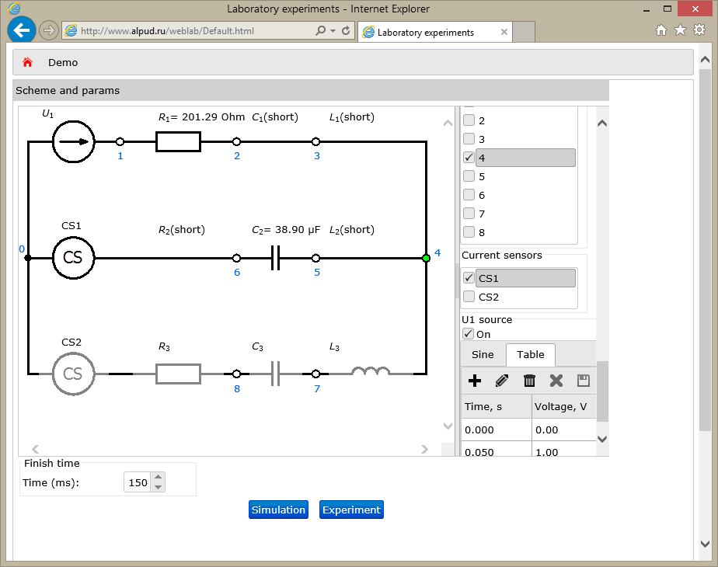
Fig. 4. The appearance of the assembled scheme with established parameters

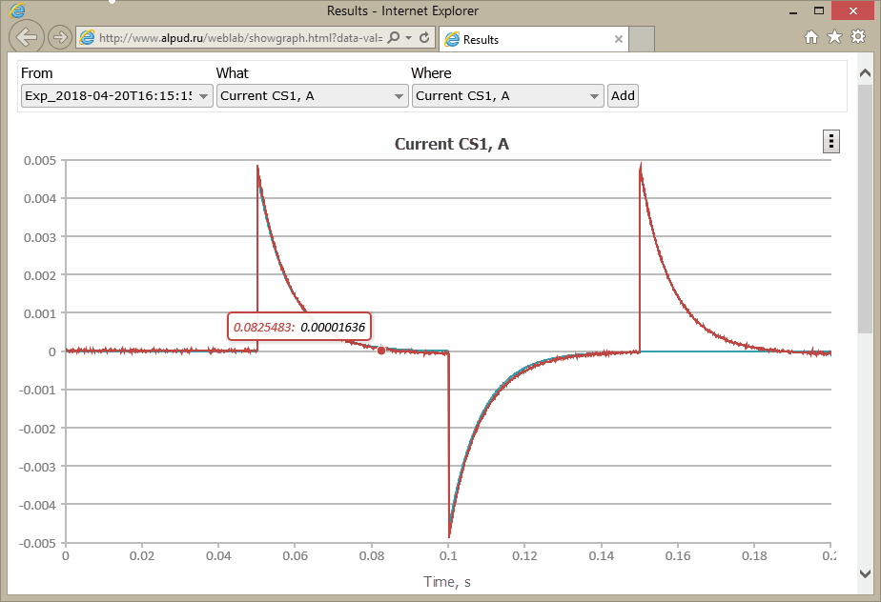
Fig. 5. Current graph of the circuit

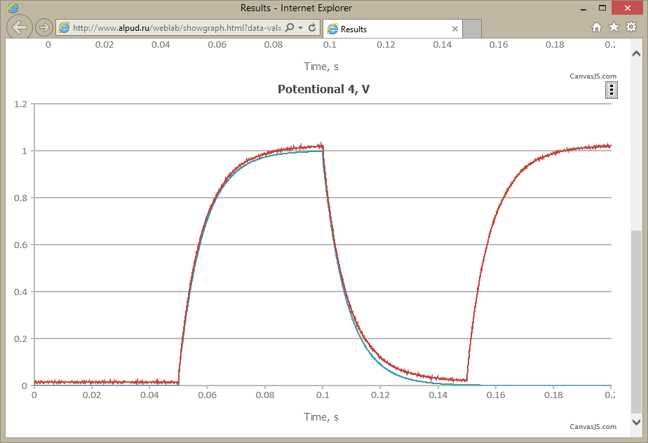
Fig. 6. Voltage graph of the capacitor
Unlike the voltage (Fig. 5), the current of the circuit changes by a spike to the level ± 5 mA and then decreases gently to 0. Such results fully correspond to the present theoretical thesis of the process in RC- circuits at the impulse of input voltage change.

Conclusion
Investigated in the article approach to create automated laboratory with a remote access to the Internet enlarges the borders of educational laboratories and gives way to form an open engineering education. The important feature of the shown approach is the opportunity to create ALW RA not only in sphere of electronics and electrical engineering but also in the related subjects such as ‘Metrology’, ‘Theory of engineering experiment’, ‘Automation measuring’, ‘Information transfer’, ‘Computerized results processing’, etc.
References
[1] A. Arodzero. World Wide Student Laboratory Project. - Los Alamos National Laboratory E-library, Physics #9806044. February 20, 1995. Revised June 19, 1998. 8 p.
[2] M. Kazitov and V. Nelayev. Active virtual laboratory at Internet as an effective tool for learning. Global Congress on Engineering Education, Cracow, Poland, Sept. 6 - 11, 1998.
[3] Visionary Physicist Uses WWW To Create World-Sized Lab. - HellerReports #3552, July 16, 1999.
[4] World Wide Student Laboratory. SBIR Grant # 0232861. NSF, DMI-0232861, 2003.
[5] Hardison, J., "An Open-Source Export Package for the MIT Microelectronics WebLab," Advanced Undergraduate Project, MIT, June 2002.
[6] Lin, Y., "A Collaboration System and a Graphical Interface for the MIT Microelectronics WebLab, " Masters of Engineering thesis, MIT, June 2002.
[7] Nasser, P. "Remote Microscope for Polymer Crystallization Weblab," Masters of Engineering thesis, MIT, 2002
[8] A.M. Zimin. The Role of Automated Remote Assessable Laboratories in a Practical Preparation of Students. Russian Federal State Agency of Education, N.E. Bauman Moscow State Technical University. Moscow, 2006. 45 p. (in Russian)
[9] S.A. Podlesniy The concept of typical decisions of automated laboratory workshop with a remote access construction (on the basis of radio engineering specialty subjects) / S. A. Podlesniy, A. V. Saraphanov, V. A. Komarov. – Krasnoyarsk: IPC KSTU, 2005. – 40 p.
[10] S.A. Podlesniy Electronic education and supply of its quality, "Engineering education", ed. 12, 2013. – pp. 104-111 (in Russian)
[11] Arbuzov U.V., Lenshin V.N., Sviridov V.G. Educational laboratory workshop in the structure of of a remote education. – Informatization problems. Theoretical and practical scientific magazine RAS. - M., 1996, ed. 3, pp. 40-45. (in Russian)
[12] New approach to the engineering education. Theory and practice of the open access to information and technical sources / U.V. Arbuzov, V.N. Lenshin, S.I. Maslov and others.; Under edition. A.A. Poliakov. – M.: Centre-Press, 2000. (in Russian)
[13] Industrial standard 9.2-98. Systems of automated laboratory workshop. Basic provisions. – M.: Rosstandard, 1998. (in Russian)
[14] Reports of TNS Russia for 2017 http://www.tns- global.ru/services/media/media-audience/internet/ (in Russian)

